Endependence Center (ECI)
aims to assist people with
disabilities in obtaining or
maintaining their desired level
of independence with the
use of services, supports, and
advocacy and advocates for
the integration and inclusion
of people with disabilities
in all aspects of society.

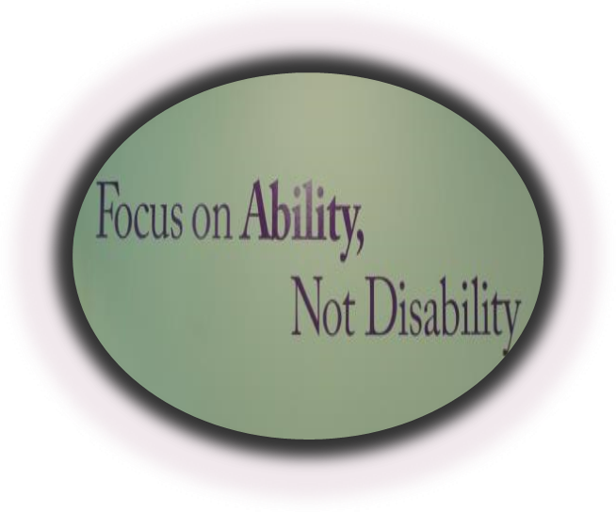

ENDEPENDENCE CENTER, INC.
6300 EAST VIRGINIA BEACH BLVD
NORFOLK, VA 23502-2827

Endependence
Center

“Opening Doors to Opportunities”

Endependence Center, Inc., (ECI)
is a non-residential, community-
based Center for Independent
Living that is directed by and assists
people with disabilities to lead
independent, productive lives.

THIS MEANS EXERCISING
THE RIGHT AND
OPPORTUNITY TO CHOOSE . . .

● A LIFESTYLE
● AN EDUCATION
● A CAREER

The individual, the community, and the Center work together to create expanded opportunities
for people with disabilities.

For more information, contact us at
(757) 461-8007 Voice
(757) 461-7527 TTY
(757) 455-8223 Fax 1st Floor
(757) 461-5375 Fax 2nd Floor
Virginia RELAY (711)
www.endependence.org
ecinorf@endependence.org
CORE SERVICES

Peer Mentoring
Connecting with other people with disabilities for support and opportunities to share valuable life experiences.

Information and Referral
Gain an understanding of information and
community resources available to you.

Independent Living Skills Training
Receive guidance and training to enhance your knowledge and develop skills to lead a more independent life.

Transition
Receive transition assistance with:
Prevention of institutionalization;
Youth transition to post-secondary life; and
Relocating from a nursing facility into the community.

Individual and Systems Advocacy
Assistance is provided to individuals with disabilities to resolve discrimination complaints in areas such as housing, education, public accommodations, employment, transportation,
and community/government programs.

Participates in policy development, regulatory processes, and program implementation in response to invitation on complaint on local,
state, and national levels.
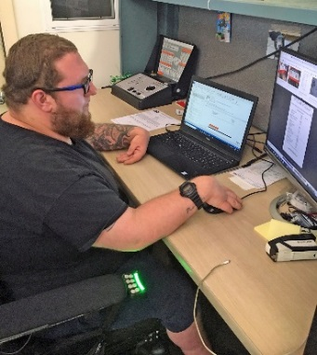

Assistive Technology for Deaf or Hard of Hearing
Technical assistance, equipment distribution and training, and disability awareness services for individuals who are deaf or hard of hearing.

Career Supports
Receive guidance and training on how to remove barriers to employment and support
so you can remain successfully employed. Receive information on work incentives
and Ticket To Work.

Community Education*
ECI organizes and conducts workshops on disability-related topics.

Technical Assistance*
ECI surveys public and private facilities to determine economical and efficient accessibility. Technical training programs
are developed for private and public agencies on compliance with disability related laws.

Accessible & Affordable Housing Information
ECI provides resource information on affordable and accessible housing in our service area.

*Fees may be associated with some of these services.

