Children’s Challenging Behaviors

A Class for Parents of Children With Mental Health Needs (ages 16 and under)
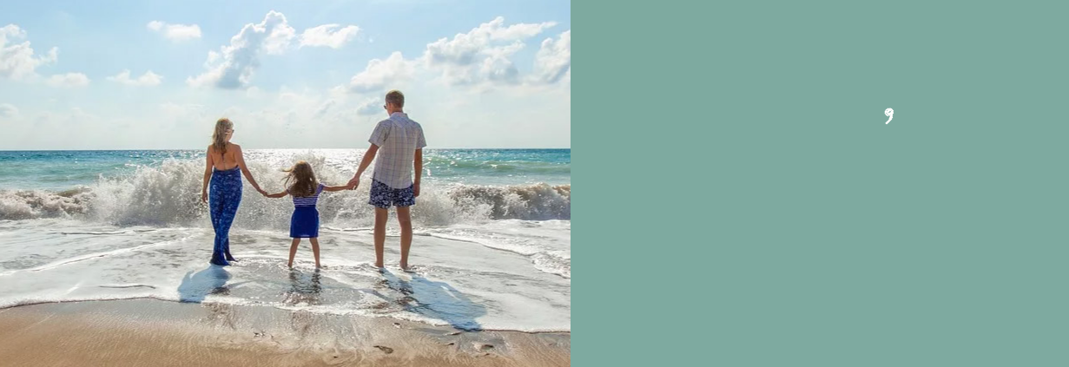

Saturday

February 1, 2020

10:00 a.m. - 4:00 p.m.

VB Strong Center in Partnership

with Sentara Healthcare

3388 Princess Anne Rd.

Virginia Beach, VA 23456

e class is taught by trained parents who provide first-hand experience and knowledge. You will receive a comprehensive class manual. Lunch is included! Childcare stipends are available

To register or for more information:
Call Susannah at 757-214-2227 tsuroskie@gmail.com

CLASS is FREE but registration is required

You Will Learn:

- Typical vs challenging behaviors and how to respond

- Who to call for help

- Available community resources

- The ins and outs of special education and other educational supports

- Parenting strategies

Sponsored By:
Coastal Virginia

Developed by NAMI Virginia as part of the Virginia Family Network

291 Independence Blvd., Suite 542 |  | www.namicoastalvirginia.org |  | contact@namicoastalvirginia.org
Virginia Beach, VA 23462 |  |  |  | (757) 499-2041

